RC CAR

OBJECTIVE:

* TO MAKE A SIMPLE RADIO-CONTROLLED CAR WHICH HAS THE CAPACITY TO PERFORM BASIC FUNCTIONS
* TO WITHSTAND THE CHALLENGES SUBJECTED TO AND OUTPERFORM OTHER CARS
* TO MAKE AN AFFORDABLE RADIO-CONTROLLED CAR ON OUR OWN WITHOUT THE USE OF READYMADE CARS OR OTHERS HELP.

MATERIALS REQUIRED: 2 plywood boards of 15*30cm, a 10*20cm teak wood sheet, a Fevicol bottle,18 screws,10 nails,4 u-bend clamps (interior components in next sheet).

DESIGN:

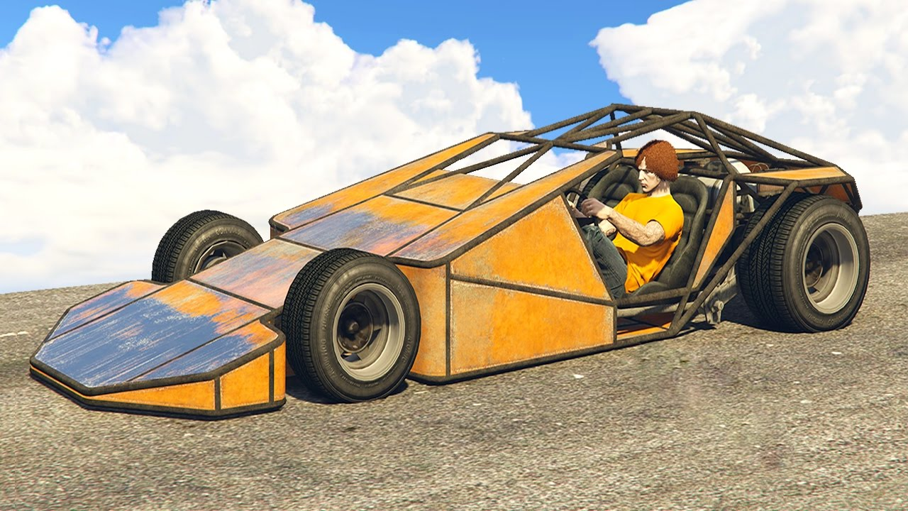

PROCEDURE:

**PART 1-THE CHASSIS**

1. FIRSTLY, WE HAD JOTDOWN ALL THE COMPONENTS REQUIRED TO MAKE THE RC CAR AND STARTED STEP BY STEP.
2. TAKE A PLYWOOD BOARD AND CUT IT AS REQUIRED TO MAKE THE CHASSIS OF THE CAR.MAKE 5 MAJOR COMPONENTS OUT OF THE WOOD. (THE BASE, THE SIDES, THE BACK, FRONT BUMPER AND THE RAMP).
3. USING NAILS, ATTACH THE BASE TO THE BACK OF THE CHASSIS.
4. DRILL HOLES IN THE BASE AND THE SIDES FROM THE BOTTOM AND ATTACH THE TWO USING SCREWS.
5. DRILL HOLES IN THE BASE AND FRONT BUMPER FROM UNDERNEATH AND ATTACH THE TWO USING SCREWS.
6. DRILL HOLES TO ATTACH THE RAMP AT THE BACK AND FRONT (DO NOT ATTACH IT COMPLETELY AS WE HAVE TO INSTALL THE INTERIOR COMPONENTS).

**PART 2-ATTACHING THE WHEELS AND MOTORS TO THE CHASSIS**

1. ATTACH THE MOTORS AT THE FRONT TO THE FRONT BUMPER AND THE BASE USING U-BEND CLAMPS AND FIX THE WHEELS TO THE SHAFT OF THE MOTOR.
2. ATTACH THE MOTORS AT THE REAR BEHIND THE BACK PORTION OF THE CAR AND TO THE BASE USING U-BEND CLAMPS AND FIX THE WHEELS TO THE SHAFT OF THE MOTOR.

**PART 3-PROGRAMMING THE ARDUINO**

1. SOLDER THE JUMPER WIRES TO MAKE A COMMON PATH.
2. AFTER SOLDERING, FIX THE WIRES INTO THE ARDUINO UNO BOARD AND THE POWER SWITCH BOARD.
3. THEN, FIX THE WIRES INTO THE ARDUINO UNO BOARD AND THE BLUETOOTH TRANSMITTER.
4. CONNECT THE ARDUINO UNO PROGRAMMER TO THE LAPTOP AND USING THE ARDUINO SOFTWARE PROGRAMME THE BOT AS REQUIRED (WE ACQUIRED THE CODES ONLINE AND MODIFIED THEM AS PER OUR REQUIREMENTS).
5. AFTER FINISHING THE PROGRAM UPLOAD IT UNTO THE ARDUINO UNO BOARD.
6. CONNECT A 6V BATTERY WITH POSITIVE TERMINAL CONNECTED TO THE VIN PIN AND NEGATIVE TERMINAL TO THE GND PIN.

**PART 4-MOUNTING THE COMPONENTS INTO THE CHASSIS**

1. CAREFULLY MOUNT THE COMPONENTS INTO THE CAR STRATEGICALLY.
2. CONNECT THE BATTERY TO THE MOTOR USING INSULATED COPPER WIRES.
3. AFTER MAKING CONNECTIONS TO ALL THE COMPONENTS, ATTACH THE RAMP ON TOP OF THE CAR AND FIX IT USING SCREWS.

**PART 5-PAIRING THE BLUETOOTH TRANSMITTER TO THE BLUETOOTH IN THE MOBILE**

1. INSTALL THE ARDUINO CAR BLUETOOTH APP ON THE MOBILE AND PAIR IT WITH THE TRANSMITTER ON THE CAR AND DONE!!! THE CAR CAN NOW BE OPERATED.

# **WEDGIE**

COMPONENT:

* ARDUINO UNO
* Motor driver module
* BLUETOOTH Module
* 500 RPM MOTORS (X4)
* 6V/4.5AMP BATTERY
* 4 WHEELS

PROCEDURE:

To make a Wedgie (ramp car), we need to start with the chassis as per the design.

After the chassis is made connect the motors to all the 4 corners as per the design.

Program the Arduino uno.

Connect the Arduino uno to the Bluetooth

sensor and the power switch board it.

Fix the wheels to the motors.

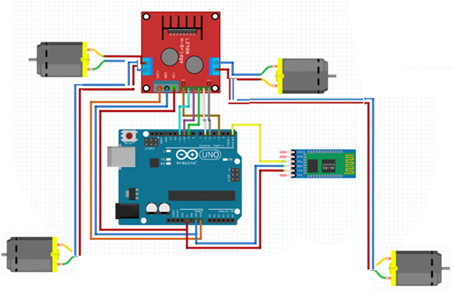

PROBLEMS FACED DURING THE PROCEDURES:

The problems faced during the procedures were programming the Arduino uno, as i wanted code specific to our functions. I faced problems soldering too.

PROBLEMS CURRENTLY:

Have problems in turning the car properly as we did not use axles and used Arduino uno and the switch board.

PROJECT DONE BY:

Mehtab Shaik